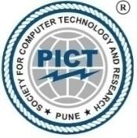 | SCTR’s PUNE INSTITUTE OF COMPUTER TECHNOLOGY, PUNE
 | S.No.-27, Pune Satara Road, Dhankawadi, Pune-411043

Department of Basic Sciences and Engineering (F. Y. B. Tech.)

Co- Curricular Activity (CCA)
Academic Year: 2025-26

Semester II Course Code: [F024] CCA-2

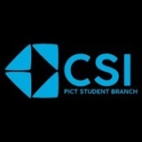
Activity: PICT CSI STUDENT BRANCH
Activity Report

Name of the Student: Vedant Rajendra Sonawane
Roll No: 10763
Enrollment No.: F25CE218

Introduction:
The Computer Society of India (CSI) is the largest and most established body of computer professionals in the country. Founded in the early era of computing, CSI has consistently worked as a non-profit organization committed to the advancement of computer science and information technology in India.
The PICT CSI Student Branch (PCSB), established in 2016, has grown into a vibrant and active student community with over 1,000 members. The branch organizes a variety of technical and non-technical events throughout the academic year, including hackathons, seminars, and workshops, all aimed at fostering innovation, enhancing skills, and encouraging collaboration among students.
One of the most anticipated events organized by PCSB is Xenia, our annual flagship technical fest. Xenia '26 is designed not only to promote technical excellence but also to provide a platform for creative expression and interdisciplinary collaboration. This three-day fest attracts participants from diverse backgrounds and offers a blend of technical competitions and non-technical events, celebrating innovation, creativity, and knowledge sharing.

Introduction Meet:
To kickstart the academic year, the PICT CSI Student Branch (PCSB) organized an introductory meet aimed at familiarizing students with the club's vision, annual roadmap, and flagship event — Xenia '26. The session was led by CSI President Prajwal Padole, along with the core team, who provided a comprehensive overview of how Xenia would unfold, including event categories, participation guidelines, and key dates.
Students were also briefed on the wide range of activities planned by PCSB throughout the year, such as workshops, seminars, and hackathons. An interactive Q&A segment followed, during which final-year seniors addressed queries, resolved concerns, and shared valuable insights to help junior members better engage with the club and balance their academic commitments. The meet served as a strong foundation for the year ahead, fostering enthusiasm and building a sense of community among the members.

30-Hour Report for Club Activity: CSI (Xenia’ 26 and Web Development)
This report outlines the contribution made towards the successful organization and participation in various PCSB (CSI) events, including Xenia’ 26 and the Web Development Sessions, totalling up to more than 30 hours of active involvement across multiple dates.

1.Date: 5th February,2026
Activity: Xenia’ 26 Publicity
Duration: 2 Hours

Description: I helped my seniors in promoting our event at PVG college pune , explaining the students of different years about our flagship event Xenia’ 26.

2. Date: 13th February, 2026
Activity: Xenia’ 26 Opening Ceremony
Duration: 2 Hours
Description: Attended the Opening Ceremony in which seniors cheered up the attendees and chief guests, sponsors and the director of the PICT; Dr. P.T. Kulkarni Sir all of them gave the short speech. Hoisters gave the brief description of upcoming events and plan of 3 days event.

3. Date: 13th February, 2026
Activity: Vault of Multiverse
Duration: 2 Hours
Description: Vault of Multiverse i.e. Treasure Hunt that I participated with my team and played well. In this event there were 16 questions out of which our team was able to solve all the questions and we came 2nd in the rankings.

4. Date: 14th February, 2026
Activity: Prompt Craft
Duration: 2 Hours
Description: This was our most enjoyed non-technical event that my team participated. In this event it had 2 rounds in which we successfully cleared the round 1 but lost at round 2. Still, it was highly enjoyable by my team. In this event we had to generate the exact image shown to the 1st person who would whisper it to 2nd person in chain and lastly that last person would give away the prompt to their desirable AI. In round 1 we managed to generate correct 6 images out of 10 shown and in round 2 we could manage to generate 5 images out of 12 shown.

5. Date: 14th February, 2026
Activity: Fate Board
Duration: 2 Hours
Description: This was the last non-tech event scheduled in Xenia’ 26 and the last one we participated. This was nice event and fate board meaning we had to play LUDO but the human ludo in which the team member of one team rolls up the die and the other member moves. There was also one sabotage per team to face definitely and one advantage per team that made the game interesting. Also, there was time bound of 15 minutes because there were many teams to play. The winner was simply that one team who finishes of the game first or have moved the most squares. We were doing better than other teams but our luck was so poor and bad that landed our team in second position. But it was a refreshing event that happened at evening after tiring work from whole day.

6. Date: 15th February, 2026
Activity: Hackathon Volunteering
Duration: 9 Hours
Description: This was the last technical event in Xenia’ 26 in which I was a student volunteer who helped in the smooth management of the event. There were three domains, first one was the FY special domain, second one was organised by the social booster media team and third one was organised by neuramach.ai team. The experience of volunteering a hackathon was completely new for me and helped me in understanding the environment of a hackathon.

7. Date: 15th February, 2026
Activity: Xenia’ 26 Closing Ceremony
Duration: 2 Hour
Description: That last hour was the last milestone crossed by the Xenia’ 26 which ended successfully. In this ceremony there was the speeches given by the seniors, faculty head of this PCSB who were Assistant Professor Mayur Chavan and finally the sponsors from which one of them was from NeuraMach AI. Following these great speeches which were motivating and congratulating the prize distribution began to the winners and runner-up of the 9 events that happened so far. At last judges left and PCSB members stayed behind and the final year seniors had an unofficial chat and discussion with all of us. They shared lots of thing like what they used to be when they were just freshmen, how did they evolve during these years and what are the key takeaways. Also, the PCSB President Mr. Adnan from 2025 Graduated batch visited us and gave us their insights. Final Year Seniors also felicitated the work of juniors and sophomores. We had a great and happy end of Xenia’ 26.

8. Date: 19th March, 2026
Activity: Web Development SIG: Session 1
Duration: 2 Hours
Description: From this session onward our first step; the basic learning towards Web Development starts. Having knowledge of webdev is good and it definitely helps in placement or the technical jobs further. In this session we learned the basics of HTML and CSS which can help develop beautiful web pages.

9. Date: 20th March, 2026
Activity: Web Development SIG: Session 2
Duration: 2 Hours
Description: In this session we learnt more about CSS moreover about Tailwind CSS which is the best used when you have to develop a good frontend and too many webpages or your U.I is kind of complex. Therefore, using Tailwind CSS in which the style.css is just in the html file and no extra file needed to create.

10. Date: 21st March, 2026
Activity: Web Development SIG: Session 3
Duration: 2 Hours
Description: In this session we learnt about JavaScript which is the main logic behind any website. The JS code can be found in the console section when we click inspect in any webpage. From this point onwards we are going to learn MERN Stack Development meaning; Mongoose DB (NoSQL), Express JS, React JS and Node JS.

11. Date: 23rd March, 2026
Activity: Web Development SIG: Session 4
Duration: 2 Hours
Description: Introduction to the React library, focusing on the component-based architecture. We learned how to set up the environment and create our first functional components.

12. Date: 24th March, 2026
Activity: Web Development SIG: Session 5
Duration: 2 Hours
Description: Advanced exploration of React concepts, including state management (useState) and passing data between components using props to build dynamic interfaces.

13. Date: 25th March, 2026
Activity: Web Development SIG: Session 6
Duration: 2 Hours
Description: Introduction to Node.js as a runtime environment. We covered the server-side basics, including setting up an Express server to handle HTTP requests.

14. Date: 26th March, 2026
Activity: Web Development SIG: Session 7
Duration: 2 Hours
Description: Continued backend development with Node.js and performed the initial installation and configuration of MongoDB to prepare for database integration.

15. Date: 27th March, 2026
Activity: Web Development SIG: Session 8
Duration: 2 Hours
Description: Hands-on practice with MongoDB using (Mongosh). We learned how to perform CRUD (Create, Read, Update, Delete) operations and write database queries.

16. Date: 30th March, 2026
Activity: Web Development SIG: Session 9
Duration: 2 Hours
Description: Deeper dive into React, focusing on hooks like useEffect for handling side effects and data fetching from APIs.

17. Date: 31th March, 2026
Activity: Web Development SIG: Session 10
Duration: 2 Hours
Description: Integrated our knowledge to start building a "Course Selling Web App." We focused on setting up API routes and connecting the frontend to the backend logic.

18. Date: 1st April, 2026
Activity: Web Development SIG: Session 11
Duration: 2 Hours
Description: Finalized the project by refining the UI, implementing final routing, and ensuring the seamless interaction between the React frontend and Node/Express backend.

Takeaways:

- Rapid Prototyping: Practiced the skill of building functional frontend prototypes under time-bound hackathon conditions.
- AI Prompt Engineering: Honed the ability to craft precise prompts for AI image generation through competitive team challenges.
- Strategic Team Collaboration: Enhanced teamwork skills by navigating constraints and role-based tasks during high-pressure events like the "Fate Board".
- Professional Networking: Leveraged opportunities to interact with industry sponsors, faculty, and senior student leaders to gain insights into career paths.\\
- Frontend Design Evolution: Advanced from basic HTML and CSS styling to implementing complex UI designs using the Tailwind CSS framework.
- Logical Programming Skills: Deepened the understanding of JavaScript as the core logic engine for web applications, including debugging techniques.
- Full-Stack Proficiency: Gained practical experience in the MERN stack, including Mongoose (NoSQL), Express JS, React JS, and Node JS.
- API Integration: Practiced handling side effects and data fetching from APIs using React hooks like useEffect.
- Comprehensive Project Lifecycle: Managed the entire development process of a "Course Selling Web App," from database configuration to UI refinement.
- Database Querying: Developed the ability to perform CRUD operations and write database queries within the mongosh environment.

Pictures:

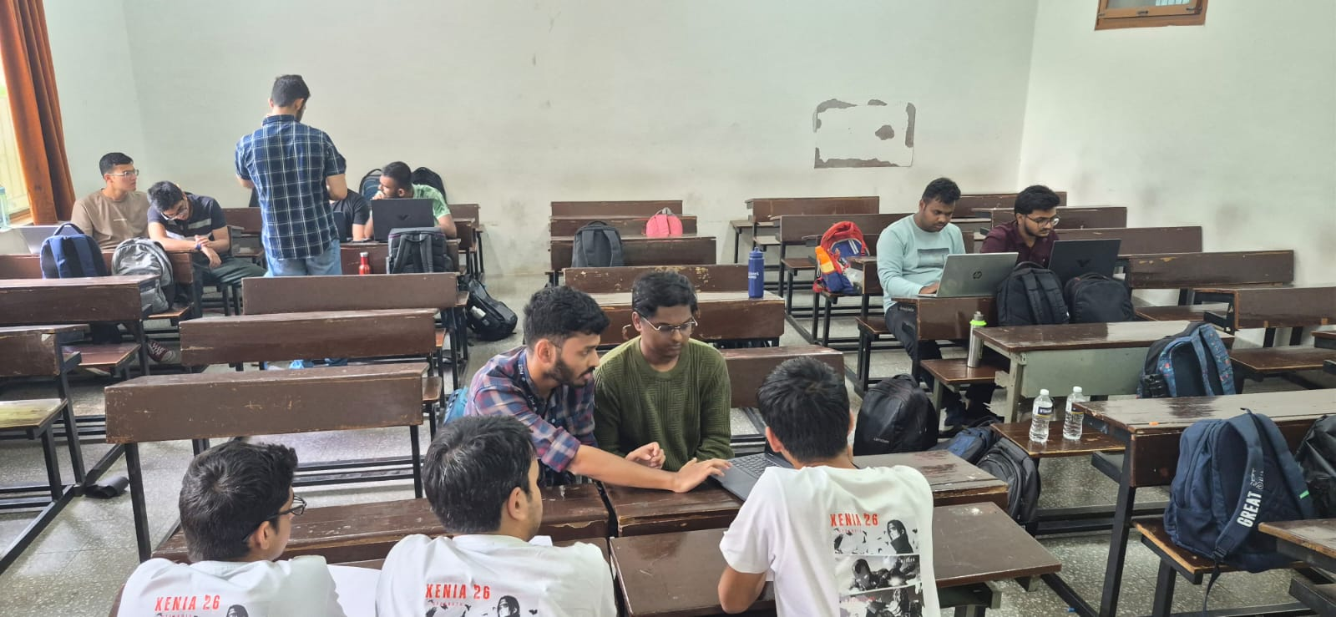

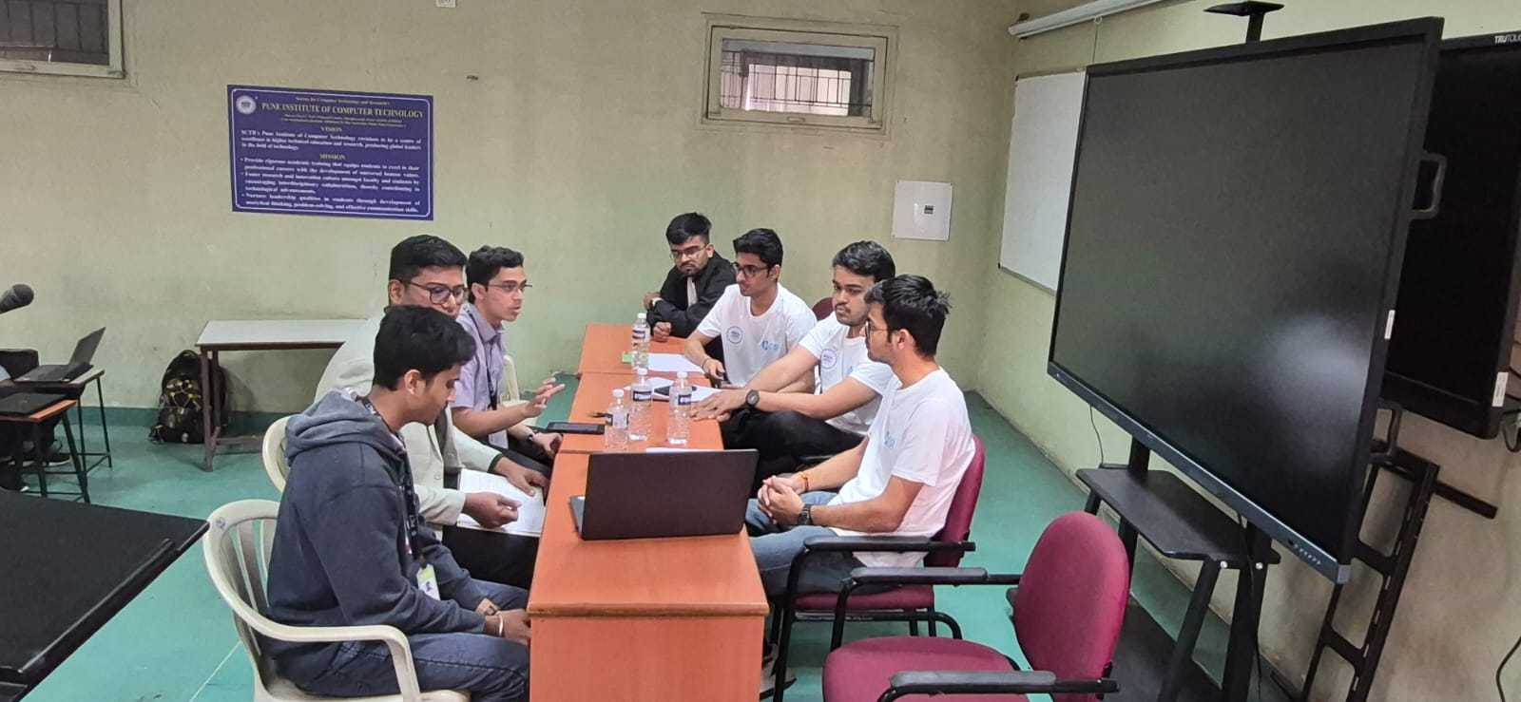

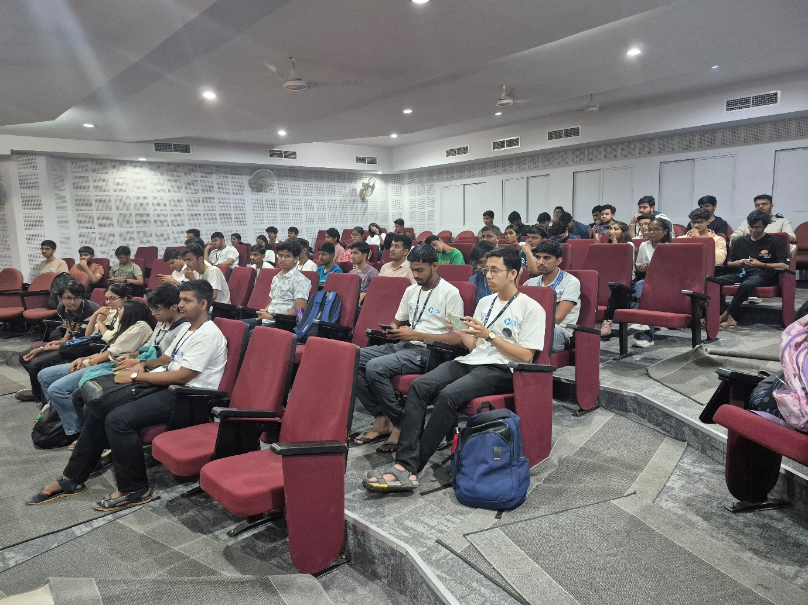

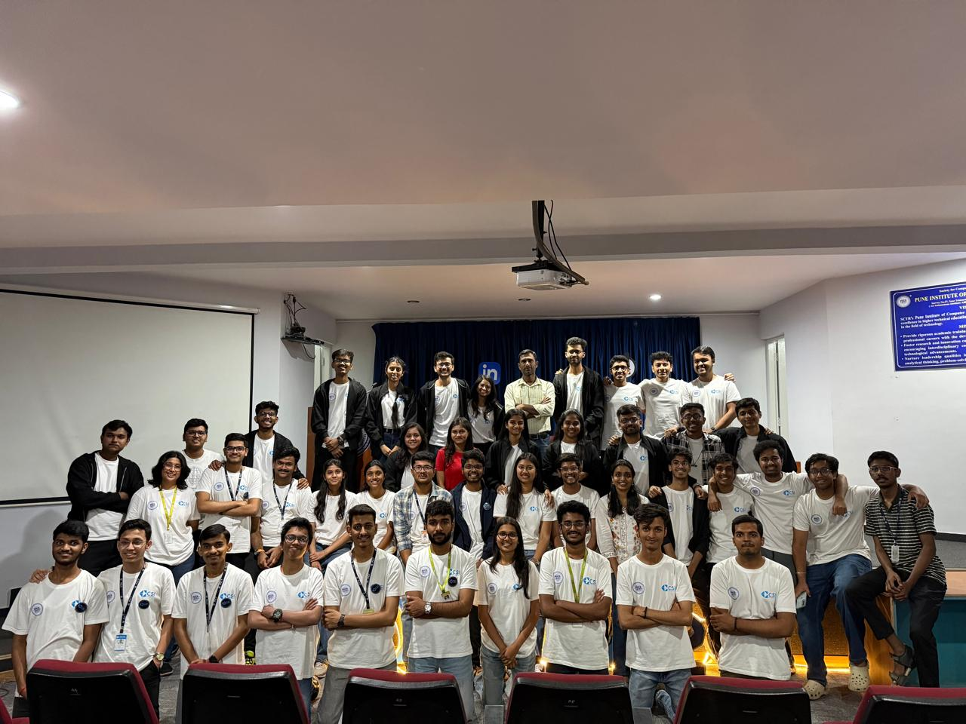

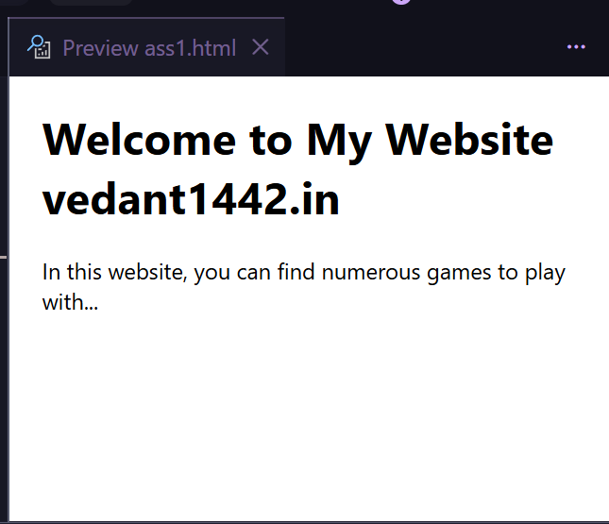

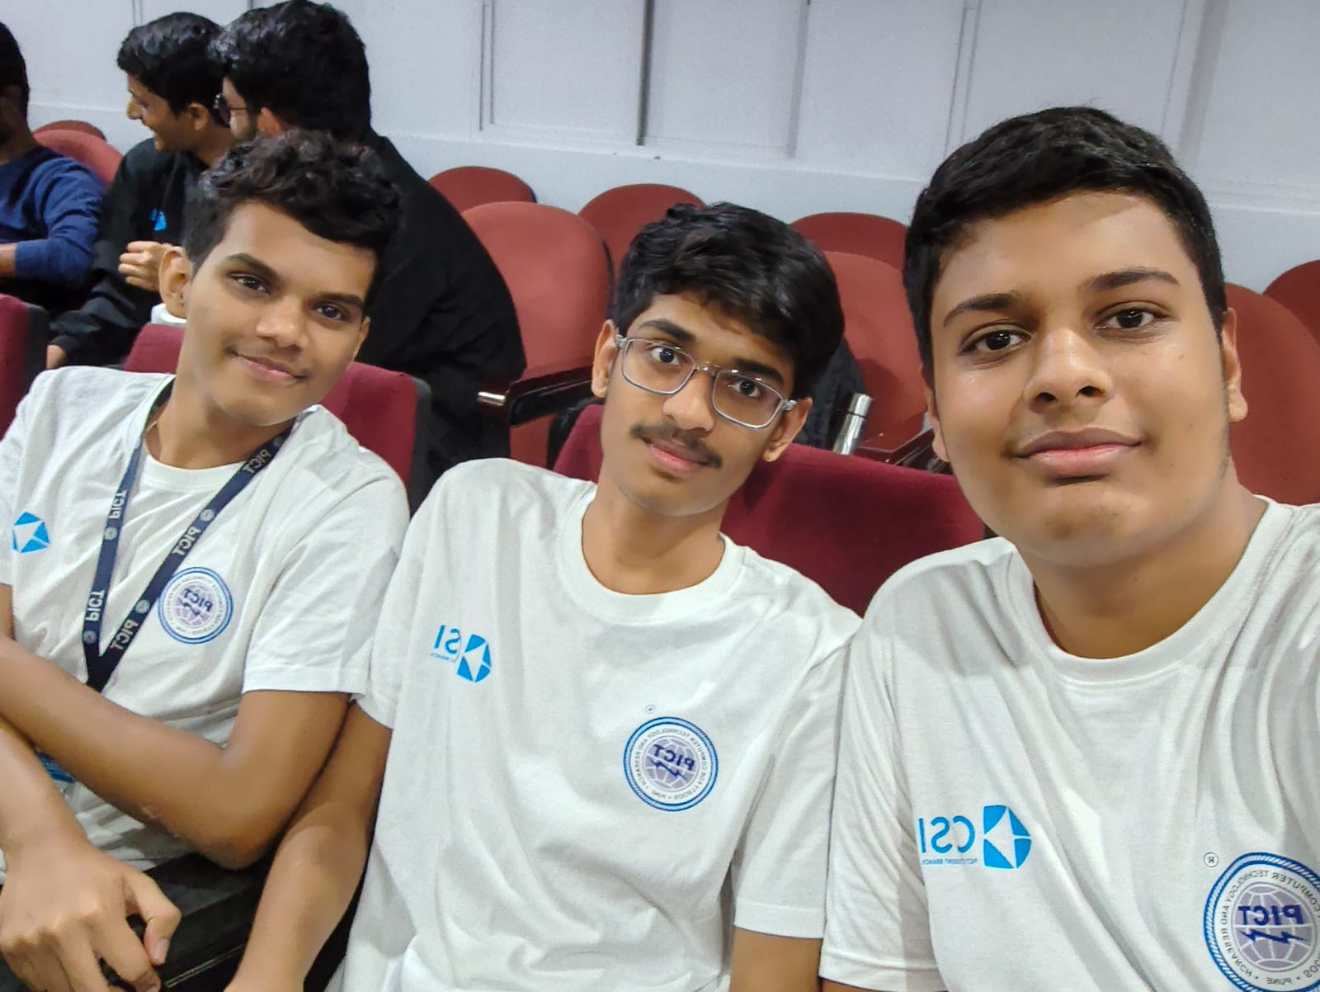

Conclusion:

Participation in the events organized by the PICT CSI Student Branch, including Xenia’ 26 and the Web Development SIG, offered a valuable blend of technical exposure, creative engagement, and organizational experience. Through diverse roles such as project development, team coordination, and active participation in hackathons, I developed essential skills in teamwork, leadership, and time management. The overall experience was both enriching and empowering, reinforcing the club's mission to foster innovation, collaboration, and continuous learning among students. By moving from conceptual technical competitions to building a fully functional web application, I have gained the confidence to handle the entire lifecycle of a software project, which will serve as a strong foundation for future professional endeavors.

